SYNOPSIS

ON

“KAVACH- A SMART CCTV SYSTEM”

Submitted in

Partial Fulfillment of requirements for the Award of Degree

*of*

Bachelor of Technology

*In*

Computer Science and Engineering

By

# Paras Gupta (1903480100071)

# Paras Gupta (1903480100072)

# Shivansh Singh (1903480100099)

Under the supervision of

**Mr. Abhay Tripathi**

**(HEAD OF DEPARTMENT CS/IT)**

**PSIT COLLEGE OF ENGINEERING**.

 Kanpur - Agra - Delhi National Highway - 19

Bhauti -Kanpur - 209305.

(Dr. A.P.J. Abdul Kalam Technical University)

1. Introduction

This is a python GUI application which can run on any operating system, uses webcam and has number of features which are not in normal Camera System.

We have used **Python language** as it is very new and comes with so many features like we can implement Machine Learning, Computer Vision and Also make GUI application with ease.

The reasons for selecting python are it is short and concise, easy to implement, supports every platform and based upon Object Oriented Programming which helps in abstraction as well.

Its Features are Anti-theft, Noise Detection, Visitors Counting, Fire Detection, Normal Recording and Face Detection.

This is a Project built using latest Programming Language and highly evolving Computer Science field which is “Computer Vision”. Which means this project allows computer to watch or in other words it gives vision capability to computers.

We have used Python based Tkinter module to design an attractive and user-friendly **GUI** interface and following features listed below:

**Theft Detection** – allows us to detect what item is stolen from the initial frame.

**Identify** – Finds the family members/recognizes faces (it has to be trained first for face recognition)

**Noise** – Finds the motions in the frame if any.

In Out – Finds out who entered and gone from the room at what time.

**Fire Detection –** It is used to detect fire in the frame.

**Rectangle –** It detects motion in the particular selected area out of the

whole frame.

1. **Project Objective**

Problem Statement :

* The motive is to make our surroundings more secure.
* Many of the times, theft occurs and the culprit escapes due to lack of security and the innocent gets caught because of face – mismatch. But this system will help to capture photos as well as identify the faces to catch the culprit.
* Using automation, the login data entry which often lacks due to human mistakes will be automated and will be accurate.

Solution :

* **It is a lot more accessible because** back in the day, CCTV cameras were highly complicated devices, requiring multiple pieces of hardware and complicated wiring. Installing and operating the system required highly trained people. Since storage was quite expensive, especially for video, often times all the feed had to be monitored in real time. Hence, only large governments and businesses could afford it. But today, you get small cameras, which you can just place on something or just stick somewhere with double sided tape if you like. The cameras connect to your existing home WiFi and require only power from any standard power outlet. Setting up can be done via simple software interfaces. Hence, it is within reach of almost anybody.
* However, just having a CCTV camera is a strong deterrent for any potential criminal.

**3.Literature Survey**

Abstract—Surveillance Systems using CCTV cameras or any other surveillance devices record the footage all the time they are active.

Most of the Data recorded is idle data where no activity takes place. When an activity which has occurred is supposed to be viewed the user has to go through all of the footage to check when and what had happened. This system eases this time consuming task. It uses Action Recognition to filter the idle movement data and trims the part where activity has been recorded using movement detection and various actions. It has a prominent scope for utilization in making the process of examining the footage from surveillance systems simple. This project could be implemented at public places and could enable respective concerned departments to investigate the data at an

amazingly rapid rate. Thus, in an era of increasing crimes rates, this project could be a breakthrough in untangling the evidence data and eventually assist in increasing the rate of crime resolution. Keywords—Surveillance System, Surveillance, Machine Learning, Neural Networks, Action Recognition, Image detection.

In the course of their evolution, western societies have developed and employed a diverse array of technologies to facilitate and co-ordinate activities, to produce and distribute goods, and to organize and administer their affairs. Modern societies have consequently come to be characterized by considerable technological complexity. Automated surveillance systems and remote monitoring devices now constitute an integral part of the prevailing technological infrastructure, enabling modes of transportation, education, government and commerce that would otherwise be unthinkable. CCTV systems, in particular, have increasingly become part of these larger infrastructures and are now ubiquitous in many urban centers. Until the mid-eighties, the deployment of CCTV systems had largely been limited to private spaces (Hempel 2001). The appearance of these systems in settings typically considered ‘public’.

It is a more recent phenomenon; and, it is one which occurred with considerable alacrity in many countries

A diverse array of aims and objectives have motivated the introduction of CCTV into public spaces including: public safety, deterrence, enhanced detection and increased response times. In the contemporary context, the predominant uses of CCTV in public spaces are in the management of risks, traffic jams, fire, accidents and crime prevention (Hempel 2001).Some have welcomed the appearance of CCTV in the public sphere. Indeed, enthusiasts of such systems cite a wide variety of direct and spin-off benefits including: a safer environment, reduced fear, raised property values, lower insurance premiums, enhanced visitor experience ,true community partnerships, and a common community purpose. Others, however, are far less sanguine. Privacy advocates worry that the proliferation of such systems in public space will lead to the disappearance of privacy. Libertarians, on both the Left and Right, have seen such

There are a variety of concerns about displacement. In this particular case, the worry is that the introduction of CCTV into one area may well block opportunities for crime in that area, but that offenders may, as a consequence, simply target another area without coverage. In other words, crime is moved,

not reduced. Others suggest that there may, in fact, be a ‘diffusion’ effect: surrounding areas (not covered by CCTV) may enjoy reductions in crime.

4. Feasibility Study:

The feasibility of the project is analyzed in this phase and business proposal is put forth with a very general plan for the project and some cost estimates. During system analysis the feasibility study of the proposed system is to be carried out. This is to ensure that the proposed system is not a burden to the company. For feasibility analysis, some understanding of the major requirements for the system is essential. Key considerations involved in the feasibility analysis are –

This study is carried out to check the technical feasibility, that is, the technical requirements of the system. Any system developed must not have a high demand on the available technical resources. This will lead to high demands on the available technical resources. This will lead to high demands being placed on the client. The developed system must have a modest requirement, as only minimal or null changes are required for implementing this system. Technical feasibility study is carried out to determine whether the proposed system has the capability in terms of software, hardware, personnel, and expertise to handle the completion of the project. The authentication systems using 3D biometrics are tolerable for circumvention. The drawback of 3D physiological and behavioral biometric recognition includes high cost, lack of powerful image processing algorithms, Dept Of CSE, CMRIT, Bengaluru - 560037 33 Smart Surveillance System Chapter 5 and low accuracy of acquisition devices. As technology advances in the manufacturing of high-speed processors and huge storage disks, the above mentioned problems are easily solved in future. Handwritten 2D signature acquisition devices are already available with assured success in signature analysis. Moreover, the proposed system utilizes the same principle of 2D signature pads with multiple devices placed in a stack and connected to a computer. The handwritten signatures of multiple layers are collected and analyzed simultaneously to produce the result of the authentication process. The proposed model with proven results through the prototype shows that the system is technically feasible to be implemented as an independent authentication system. The camera system is compact and can be implemented with low cost. The implemented face detection algorithm (Haar like cascade classifier) is very effective, with an accuracy of 88.9 percent which can be increased further by effectively improving the illumination of the area. However, this system is connected with the help of an Ethernet cable to the laptop to communicate with the raspberry pi. This can be overcome by making the system wireless.

5. Methodology/ Planning of work

Following are some features of the iterative model:

* It enables you to demonstrate and measure the progress of your project without any bias.
* The functionality of the project increases Incrementally.
* It lets you have a constant improvement in the quality of the project.
* With continuous improvements, it helps you lower down the chances of risk.
* You can experience good improvement in the accuracy of the various estimates that could be part of the project.
* It is also known as the cyclic model. After the initial phase, some phases occurs repeatedly and with the completion of each phase there is the scope of someimprovement. 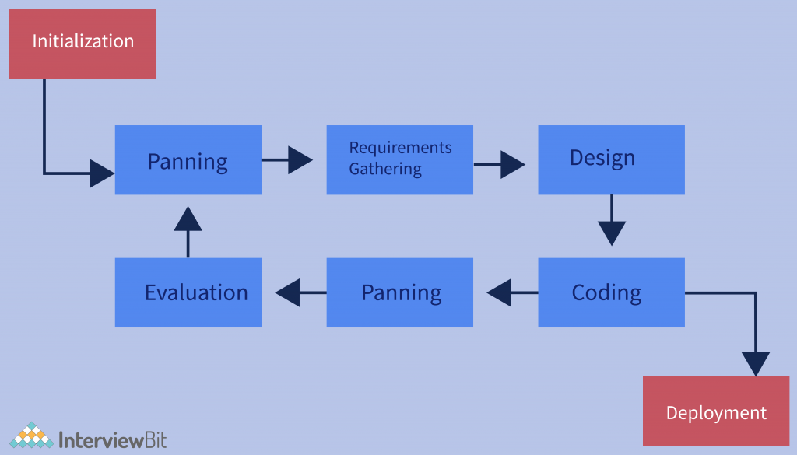
* Lastly, it helps increasing enthusiasm, collaboration, and effectiveness within the team.

6. Tools/Technology Used:

**Software Requirements**

Since this is a software hence it will have to run on some hardware and operating system obviously, so below are the requirements to run this software :

* Windows/Linux/Mac OS any version, hence it can run on any platform.
* Python3, it need python to be installed in your system to run this successfully.
* Packages in python -
  + openCV
  + skimage
  + numpy
  + tkinter

**Hardware Requirements**

In terms of hardware requirements there is not much required at all but still below requirements are must :

* Working PC or Laptop
* Webcam with drivers installed
* Flashlight/ LED if using this at night.

**Technologies used to make this project :**

* **Python** language is used.
* Sublime Text Editor is used to write the code.
* Linux Mint OS is used to run and create this minor project.
* HP-ay503tx laptop is used.
  + Core i5 dual core
  + 240GB SSD
  + 8GB RAM
  + In-built webcam- True Vision
* Terminal to run the code

Platforms already tested,

It is tested on Linux Mint, Linux Ubuntu, Windows 7, Windows 10.

7. References [IEEE format]:

The Institute of Electrical and Electronics Engineers publishes several dozen software engineering standards, including IEEE Std 830-1998, "IEEE Recommended Practice for Software Requirements Specifications." Standard 830, last revised in 1998, has since been replaced by Standard ISO/IEC/IEEE 29148:2011, with an update in 2018.

IEEE standards result from the collaboration of dozens of practitioners worldwide. They're meant to reflect the best of what is known about how to address a specific software engineering domain. However, companies don't have to follow IEEE standards, as no outside agency enforces a universal standard. Some organizations might mandate that their project teams or subcontractors follow certain standards but not others.

Generally, view IEEE standards for SRS documentation as a representation of the [collective knowledge](https://www.ieee.org/about/index.html) of many smart people who have worked on software projects over the last several decades. I recommend that you start with existing materials, like the IEEE standards, rather than create your own SRS model from scratch.

# 8.References

For making this project we have used so many websites and papers and YouTube tutorials all are below specified.

1. [waterfall model geeksforgeeks](https://www.geeksforgeeks.org/software-engineering-classical-waterfall-model/)
2. [Structural Similarity from medium](https://medium.com/srm-mic/all-about-structural-similarity-index-ssim-theory-code-in-pytorch-6551b455541e)
3. [face detection](https://medium.com/geeky-bawa/face-identification-using-haar-cascade-classifier-af3468a44814)
4. [LBPH algorithm](https://towardsdatascience.com/face-recognition-how-lbph-works-90ec258c3d6b)
5. [openCV](https://www.youtube.com/channel/UCx1_WfGX9D9rmsJNBM5qsMA)
6. [tech with tim](https://www.youtube.com/channel/UC4JX40jDee_tINbkjycV4Sg)

Also we have used so many other YouTube channels and google and stack overflow to solve our errors. Also we used Official python documentations to know basics about python.